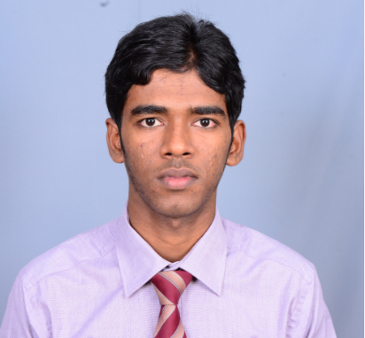Name : Thirugnanasampanthar Yokaruban

DOB : 30th June 1996

Address : Amman Kovil Road, Kondavil, Jaffna

NIC : 961820367V

Mobile : +94771660890

Tel : +940212226125

E-mail : yokaruban@gmail.com

Marital Status : Bachelor

Nationality : Sri Lankan

OBJECTIVE

To be part of a dynamic and progressive organization, that offer challenging working environment where one can utilize energies and competences in a positive direction and contribute towards overall objectives of organization.

ACADEMIC QUALIFICATIONS

* Successfully completed Foundation in AAT.
* G.C.E Advanced Level

Accounting B

Economics C

Business studies S

* G.C.E Ordinary Level

Saivasm A

Commerce B

Tamil Language & Literature C

Drama C

English C

Mathematics C

Health & Physical Education C

Science S

History S

* Asociation and clubs
* Assistant Secretary of Leo club 2015

EXTRA CURRICULAR ACTIVITIES

* Member of Commerce Union for the year 2014.
* Member of Scout Troops
* .Student Manager of Bank of Ceylon
* Actively participated in Athlete programs.
* Active member of Cricket and Football teams at St.John’s College.

ACHEIVEMENTS

* Actively participated in Athlete programs.
* Active member of Cricket and Football teams at St.John’s College.
* Winner of the inter-house cricket match
* Awarded football match in inter-house matches

SKILLS AND ABILITIES

* Strong verbal communication skills in all English & Tamil languages and manageable skills in Sinhala language and strong written skills in English and Tamil
* Ease communicating with a range of people.
* Great knowledge of numbers and ability to perform addition, subtraction,   
   multiplication and division.
* Ability to work both independently or as a team member.

OTHER QUALIFICATIONS

* Completed Diploma in Microsoft Office at G-TEC Computer Education.
* Successfully Completed G-Basic at E.com.
* Completed Diploma in English at Union educational Institute.

NON-RELATED REFEREES

(1) Rev.N.J.Gnanaponrajah. (2) Mr.T.Nanthakumaran

Principal A/L Commerce Sectional Head

St.John’s College St.John’s College,

Jaffna, Srilanka. Jaffna, Sri Lanka

Tel : +94 0212222432 Tel : +94 0771298159

**I the undersigned, certify the statements made by me here in are complete and true to the best of my knowledge.**

…………………………………. ………………………………..

T.Yokaruban Date